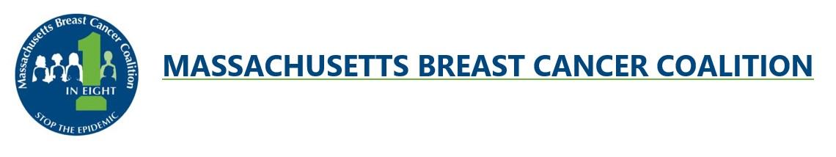
PRESS RELEASE
CONTACT: Cheryl Osimo, Executive Director
508-246-3047
cosimo@mbcc.org

Against the Tide Athletic Events to Support Breast Cancer Prevention
In-Person and Virtual
REGISTER NOW at mbcc.org/swim

Join Massachusetts Breast Cancer Coalition (MBCC) in person at DCR’s Hopkinton State Park on Saturday, June 17th for Against the Tide for its 31st year! Later in the summer, MBCC will host Against the Tide in person at DCR’s Nickerson State Park on Saturday, August 12th for the 24th year! Events include 1-mile recreational and competitive swims, a USMS Sanctioned 1-mile swim, ½-mile recreational swim, 5K and 10K runs, and a 3-mile fitness walk.

MBCC will also host an all-summer virtual Against the Tide from June 17th to August 12th. This virtual event includes 1-mile recreational and competitive swims, ½-mile recreational swim, 5K and 10K runs, and a 3-mile walk.

“This event raises the funds used for MBCC’s programs to educate about toxic chemicals that can cause breast cancer and supports its advocacy to eliminate these toxins from the environment where we and our children and grandchildren live,” says Cheryl Osimo, MBCC’s Executive Director.

Against the Tide events can be enjoyed by adults and children of all ages and abilities. Register now for one or more events at mbcc.org/swim.

All participants will receive an event t-shirt. Prizes will be awarded for the top swim and run finishers of the in-person events. Registration for both the virtual and in-person options is $40 for an individual participant and $100 for a family registration (up to 5 family members).

To learn more about all of the registration options, to join or start a team, and to donate, please visit the MBCC website at www.mbcc.org/swim or call 508-246-3047.

# # #
..

