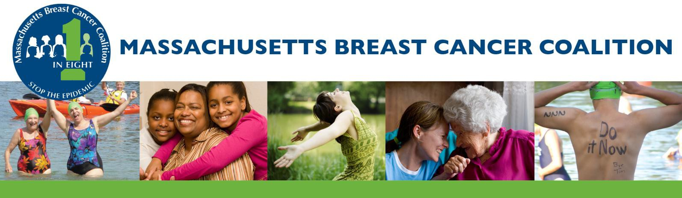

REDUCE YOUR EXPOSURE

For over two decades, Massachusetts Breast Cancer Coalition (MBCC) has advocated for increased safety of consumer products. We will continue to work for legislative reform and enforcement of policies that reduce the presence of carcinogenic and/or endocrine disrupting chemicals in these products. In the meantime, we believe consumers can take steps to reduce exposure to carcinogenic and endocrine disrupting chemicals.

- Pay attention to food packaging – Choose fresh or frozen foods over canned, and choose glass or stainless steel containers instead of plastic. If you must use plastic, avoid #3, #6, and #7. Never heat any kind of plastic food containers in the microwave.
Since World War II, over 85,000 synthetic chemicals have been manufactured and released onto the market.
Less than 10% of these have been tested for impacts on human health.

- Trust your nose – If it smells bad, it’s probably bad for you. The smell of a new shower curtain, a new car, and dry cleaned clothes are all due to hazardous chemicals that should be avoided. Instead of a plastic shower curtain, buy a cotton or nylon one. If you dry clean your clothes, ask that they be treated without tetrachloroethylene , also known as “PERC.” Many dry cleaners already follow these guidelines but make sure that your neighborhood offers safe dry cleaners too.

- Eat less char – When grilling foods, minimize char by reducing the heat level and/or using marinades. The blackened part of barbequed foods can be delicious, but it can also be hazardous to our health. Char contains polcyclic aromatic hydrocarbons (PAHs) which are known to cause tumors in animals.

- Vacuum regularly – Many toxins are released from furnishings and products as dust particles. Minimize dust by using a vacuum fit with a HEPA filter.

PO Box 202 Phone: 617-376-MBCC (6222)
Franklin, MA 02038 Toll Free: 800-649-MBCC (6222)
info@mbcc.org Learn more at www.mbcc.org

Try to Avoid These Dangerous Chemicals

BPA (Bisphenol A) used in sports bottles, baby bottles and sippy cups, food can linings, etc.

Atrazine in herbicides, weed killers, pesticides etc.

BHA in hair relaxers, skin lighteners, lipsticks, and other cosmetics.

Placenta in skin and hair conditioners, etc.

Lead in lipsticks, hair dyes,
children’s toys, etc.

Phthalates in hair spray, nail polish, deodorants and fragrance, shower curtains, and similar soft plastics.

Parabens in cosmetics, lotions, and deodorants.

Hydroquinone in skin lightening creams and gels.

Fragrance in shampoo, lotion, perfume, cologne/musk, cleaning products, etc.

Mercury in eye drops, mascara and skin lighteners, etc.

Formaldehyde in nail polish, wall board, lab preservative, aerosol products, etc.

DEA found in many household cleaning products

Xylene in floor polishers, iron aids, spot removers, etc.

Monoethanolamine in oven cleaners, tub and tile cleaners, carpet cleaners, etc.
- Choose natural and organic furnishings – Many things inside your home may be sprayed or made with flame retardant chemicals that are carcinogens or endocrine disruptors. These are commonly found in toys, plastic furniture, furniture foams and upholstery, clothing, small appliances, and wire insulation and can release toxins into the air as dust particles.

- Read labels – Before buying, read the labels of your personal care products, cleaning products, pesticides, and even furniture. Some chemicals in these products have been associated with cancer, impaired fertility, impaired brain function and birth defects. Where are they found? See a list of chemicals of concern on the left-hand sidebar. Look for products that are free of these ingredients, and don’t hesitate to ask your local retailer to sell products that are free of these toxins. There are many inexpensive healthy alternatives on the market. Your questions and demands help to bring about change.

- Explore alternatives – Research natural alternatives to cleaning products, personal care products, pesticides, and lawn care products. You’ll be amazed at what you can find!

- Use your strong citizen power – Refuse to be contaminated with carcinogens and endocrine disrupting chemicals! Visit MBCC’s Policy & Legislation page on www.mbcc.org to learn more and take action on proposed environmental health legislation.
YOUR VOICE AND ACTION IS NEEDED IN MBCC CAMPAIGNS TO PREVENT BREAST CANCER BEFORE IT STARTS!

Visit www.mbcc.org for volunteer opportunities and information about upcoming events. Stay in the loop: to receive updates, subscribe to our eNewsletter, “Like” us on Facebook at facebook.com/mbccorg, and follow us on Twitter @mbccprevention

